Software Requirements Specification
for
CRICWAVES
Prepared by
Gangam Rushik Reddy , Eluri Sriram, Chenna Sankalp
NIIT UNIVERSITY
Table of Contents
Table of Contents ii
Revision History ii
1. Introduction 1
1.1 Purpose 1
1.2 Document Conventions 1
1.3 Intended Audience and Reading Suggestions 1
1.4 Product Scope 1
1.5 References 1
2. Overall Description 2
2.1 Product Perspective 2
2.2 Product Functions 2
2.3 User Classes and Characteristics 2
2.4 Operating Environment 2
2.5 Design and Implementation Constraints 2
2.6 User Documentation 2
2.7 Assumptions and Dependencies 3
3. External Interface Requirements 3
3.1 User Interfaces 3
3.2 Hardware Interfaces 3
3.3 Software Interfaces 3
3.4 Communications Interfaces 3
4. System Features 4
4.1 System Feature 1 4
4.2 System Feature 2 (and so on) 4
5. Other Nonfunctional Requirements 4
5.1 Performance Requirements 4
5.2 Safety Requirements 5
5.3 Security Requirements 5
5.4 Software Quality Attributes 5
5.5 Business Rules 5
6. Other Requirements 5
Appendix A: Glossary 5
Appendix B: Analysis Models 5
Appendix C: To Be Determined List 6

Revision History
Name | Date | Reason For Changes | Version

Introduction

Purpose
The purpose of this document is to build an online system to watch the cricket live score and many more features to ease the user.

Document Conventions
We are using HTML and CSS language to build this website . By order the header are using H1 for title of website and it continues , at last for H6 we will use it for drop down buttons . We are using almost same fonts for the website ..

Intended Audience and Reading Suggestions

This project is a prototype for the cricket management system and it is restricted within the college premises. This has been implemented under the guidance of college professors. This project is useful for the cricket management team and as well as to the public or user and cricket lovers.

Product Scope
The purpose of the online cricket live score website is to ease cricket management and to create a convenient and easy-to-use application for users, trying to build live score . The system is based on a relational database with its cricket management for live matches and future matches . We will have a database server supporting number of teams around the world either as national teams or country match leagues as well as thousands of players by various countries . Above all, we hope to provide a comfortable user experience along with the best viewing available.

References
IEEE SRS TEMPLATE

https://krazytech.com/projects/

Overall Description

Product Perspective
A distributed cricket database system stores the following information.

1> Schedule:- This will tell us about the
a)present matches ,
b)present
c)future series
d) matches by day

Live score:- It will also provide us with real time information about game results from various disciplines.

Rankings:- It is a table where international cricket players performances are ranked using a points based system which is worked out by doing a series of calculations leading to a sophisticated moving average.

In this rankings part there are 5 categories
1. Batsmen
2.Bowler
3.All-rounder
4.wicket keepers
5. teams.

Product Functions
Records:- The sum of the past achievements or performance of a person. Basically there are four records in that drop down buttons.

Batting , bowling, wicket keeping and all fastest records.

Squad:- in this website basically we made a squad button. In that there is a search icon used for team squad by searching team name.

User Classes and Characteristics
Users of the system should be able to retrieve cricket information between two given countries with the given date/time of score from the database. A score from team A to team B is a sequence of conducting matches from A to B .

we have Buttons

Home
Schedule
Chronicles
Series
Live score
Rankings
T20 league
Records and videos

Operating Environment
Operating environment for the cricket management system is as listed below.
- distributed databasU+0065
- client/server system
- Operating system: Windows.
- database: sql+ database and php
- platform: html , css , javascript.

Design and Implementation Constraints
TECHNOLOGIES BEING USED:

Program and Code:

We are used HTML, CSS , JAVA SCRIPT to make a
web page.

Use “WIN SCP” site to create a website from the
web page.

There is one more site “COFFEE CUP” to create a
website.

For back end we will use php and sql for databases..

User Documentation
We will additionally provide a manual , tutorials , tips and game technique in this software. So, we provide a cricket user documentation to the clients.

Assumptions and Dependencies
All the idea of a project is going good but there is a small problem in implementing the idea with some additional one . Basically it is about live video match not possible because we won’t get a api to carry this idea and one more thing about animation video placing in the web site .

External Interface Requirements

User Interfaces
All the idea of a project is going good but there is a small problem in implementing the idea with some additional one . Basically it is about live video match not possible because we won’t get a api to carry this idea and one more thing about animation video placing in the web site .

Hardware Interfaces
Windows.
A browser which supports CSS, HTML & Javascript.

Software Interfaces
A browser which supports CSS, HTML & Javascript.
database: sql + database and php

Communications Interfaces
Following are the software used for the cricket online website.
Software used | Description
Operating system | We have chosen Windows operating system for its best support and user-friendliness.
Database | To save the cricket records, players records we have chosen SQL+ database.
php | To implement the project we have chosen php language for its more interactive support.

System Features

The sports system maintains information on games , upcoming matches and series , other leagues, live score and records. Of course, this project has a high priority because it is very difficult to tell live score manually .

System Feature 1

4.1.1 Description and Priority
The sports system maintains information on games , upcoming matches and series , other leagues, live score and records. Of course, this project has a high priority because it is very difficult to tell live score manually .

4.1.2 Stimulus/Response Sequences
Search for records and previous match highlights and rankings.
Displays a detailed list of available matches
search a player to know his personal and game information.

4.1.3 Functional Requirements
Other system features include:
DISTRIBUTED DATABASE:
Distributed database implies that a single application should be able to operate transparently on data that is spread across a variety of different databases and connected by a communication network.

CLIENT/SERVER SYSTEM
The term client/server refers primarily to an architecture or logical division of responsibilities, the client is the application (also known as the front-end), and the server is the DBMS (also known as the back-end).
A client/server system is a distributed system in which,
- Some sites are client sites and others are server sites.
- All the data resides at the server sites.
- All applications execute at the client sites.

System Feature 2 (and so on)
This project supports all types of web browsers. We are using simple electronic forms for the real games etc.

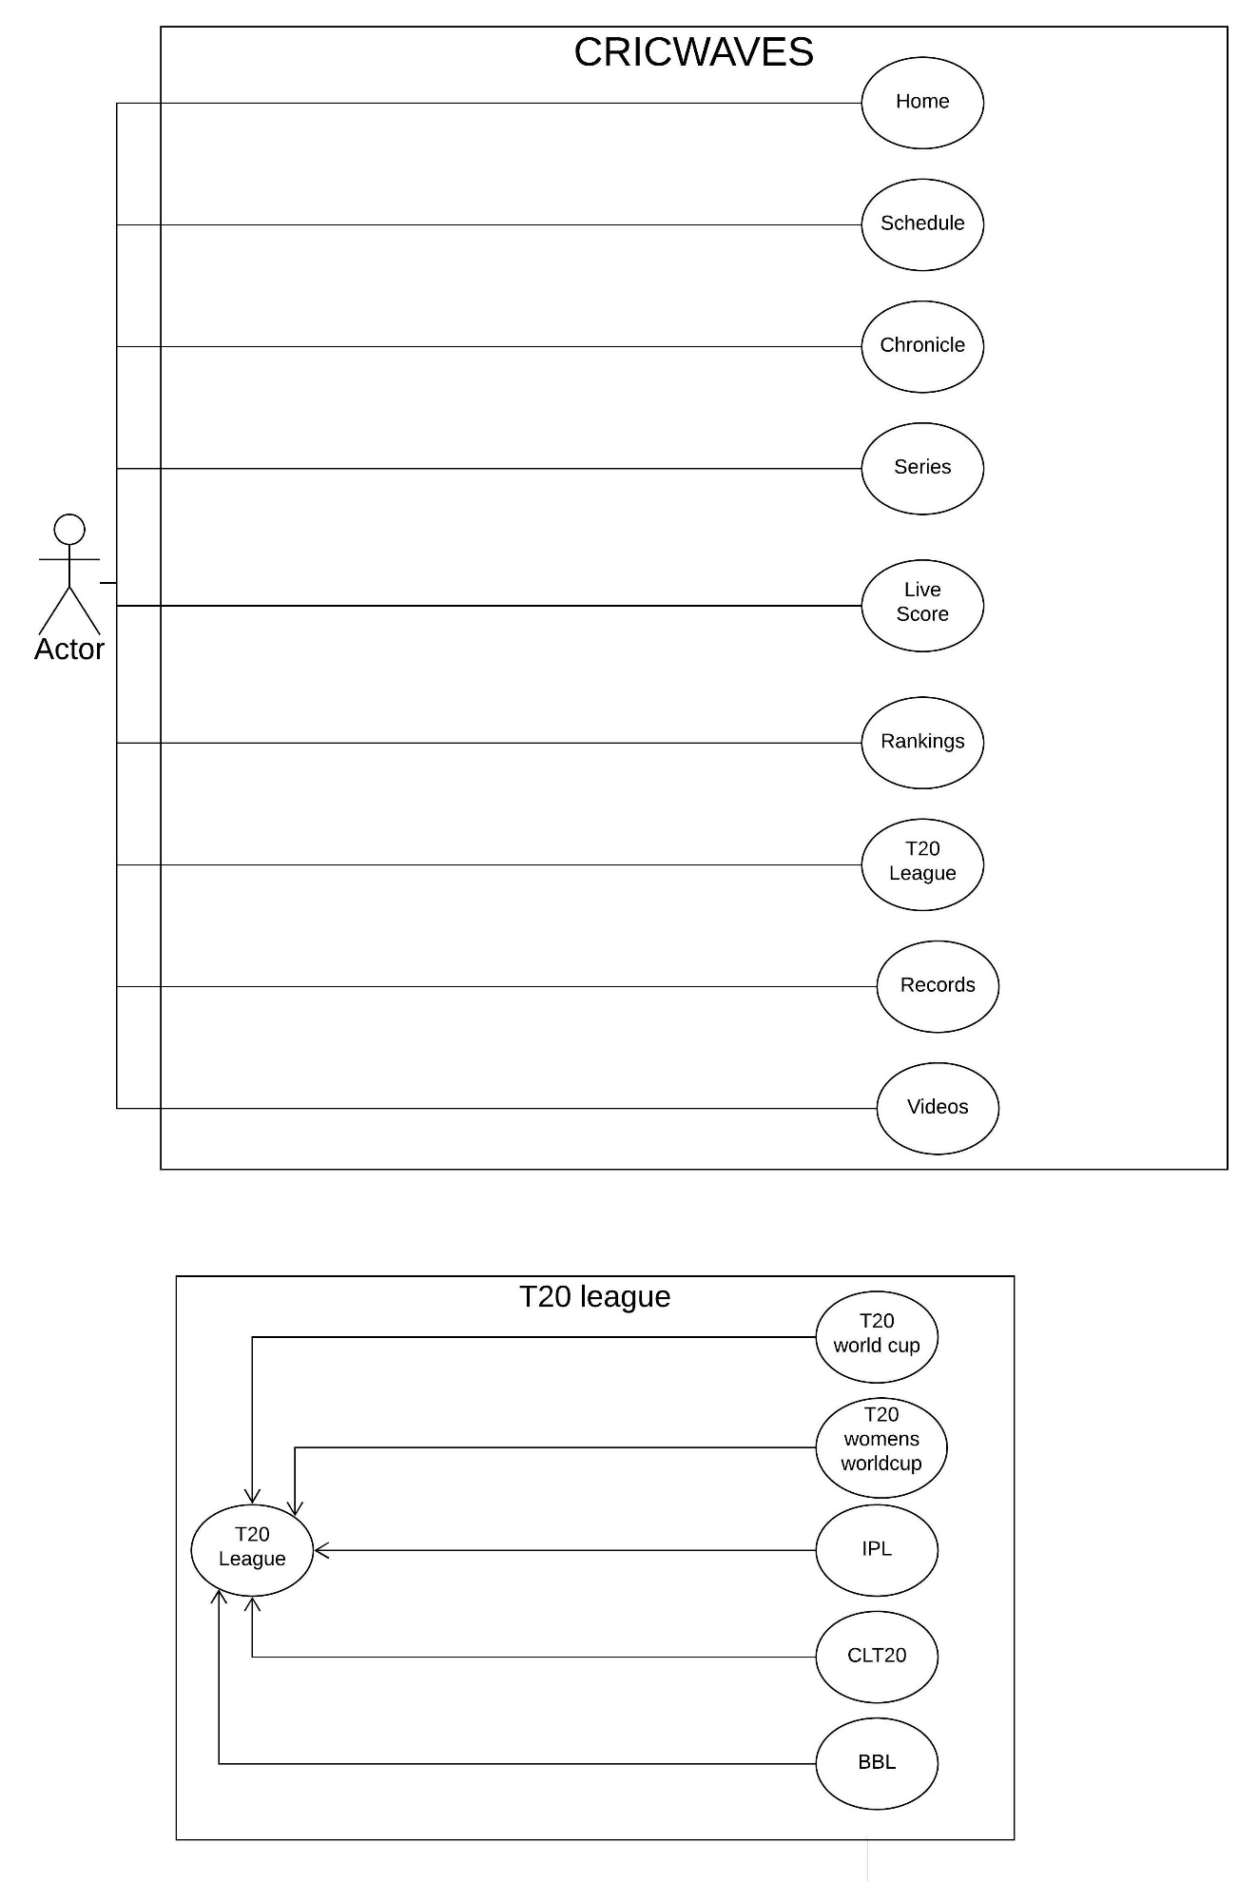
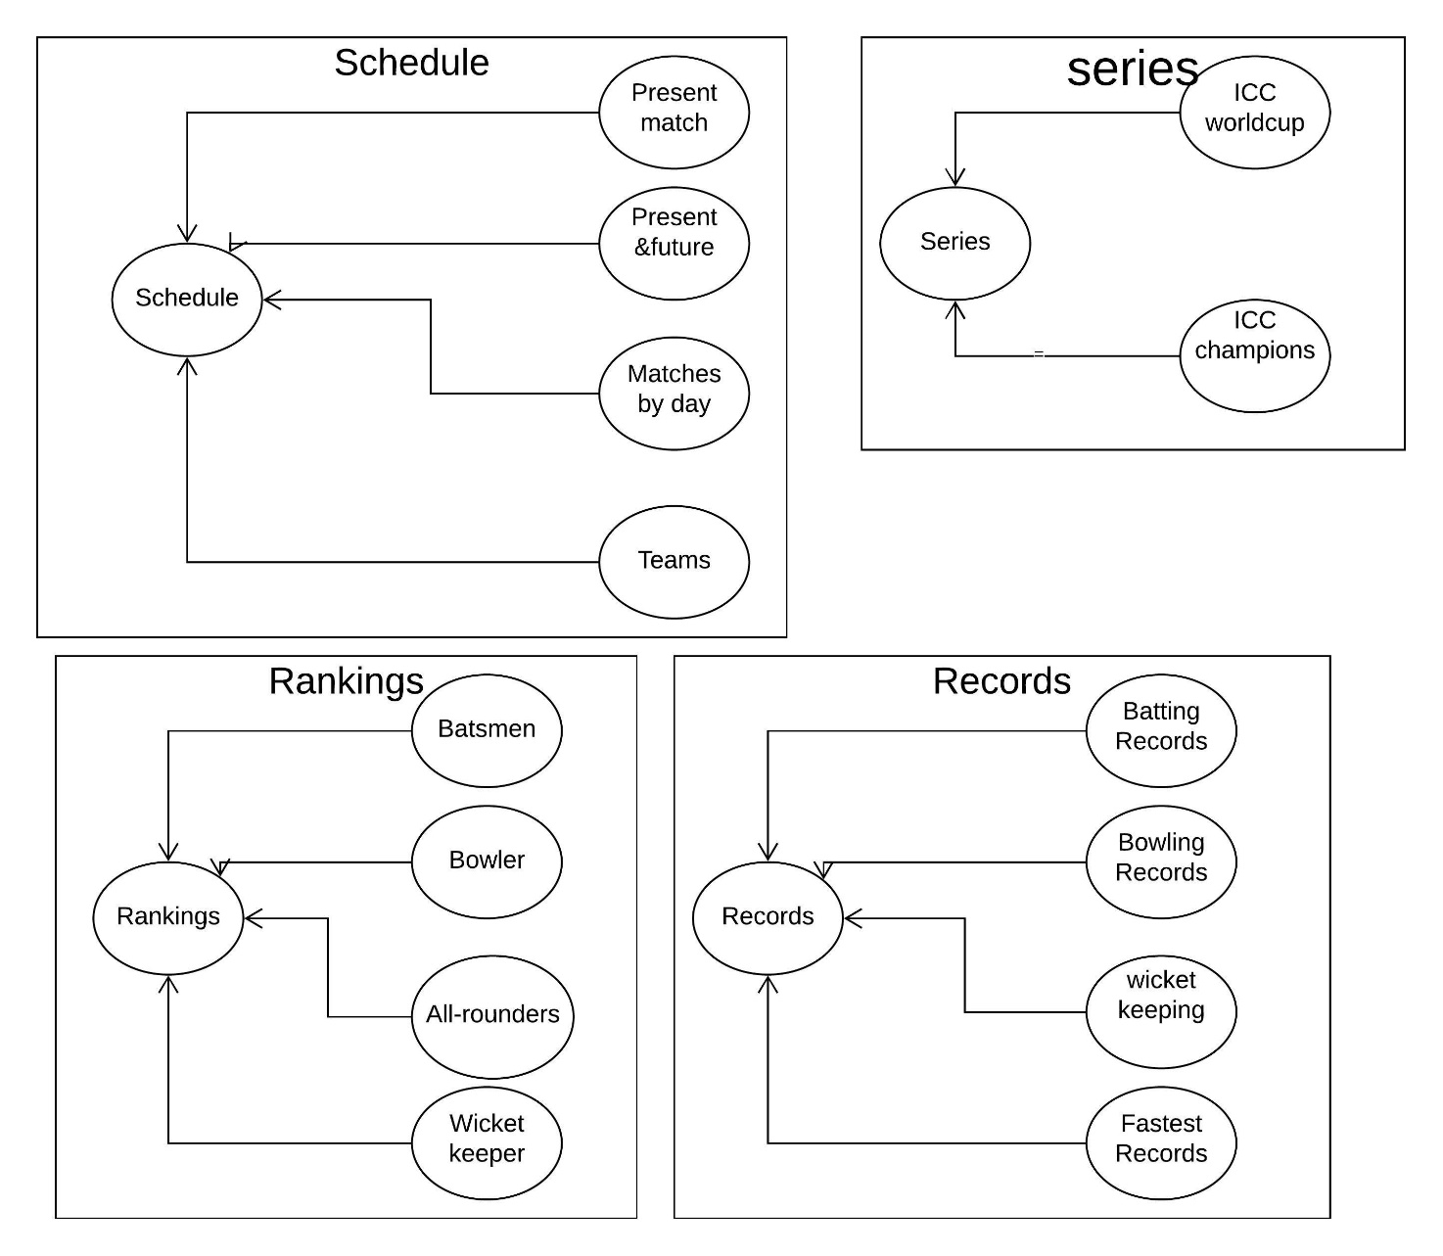

Other Nonfunctional Requirements

Performance Requirements
The steps involved to perform the implementation of cricket database are as listed below
*ENTITIES: Which specify distinct real-world items in an application.
- PROPERTIES/ATTRIBUTES: Which specify properties of an entity and relationships.
- RELATIONSHIPS: Which connect entities and represent meaningful dependencies between them.
The basic objective of normalization is to reduce redundancy which means that information is to be stored only once. Storing information several times leads to wastage of storage space and increase in the total size of the data stored.
If a database is not properly designed it can give rise to modification anomalies. Modification anomalies arise when data is added to, changed or deleted from a database table. Similarly, in traditional databases as well as improperly designed relational databases, data redundancy can be a problem. These can be eliminated by normalizing a database.
Normalization is the process of breaking down a table into smaller tables. So that each table deals with a single theme. There are three different kinds of modifications of anomalies and formulated the first, second and third normal forms (3NF) is considered sufficient for most practical purposes. It should be considered only after a thorough analysis and complete understanding of its implications.

Safety Requirements
If there is extensive damage to a wide portion of the database due to catastrophic failure, such as a disk crash, the recovery method restores a past copy of the database that was backed up to archival storage (typically tape) and reconstructs a more current state by reapplying or redoing the operations of committed transactions from the backed up log, up to the time of failure.

Security Requirements
Security systems need database storage just like many other applications. However, the special requirements of the security market mean that vendors must choose their database partner carefully.

Software Quality Attributes
- AVAILABILITY: The MATCH should be available on the specified date and specified time as many customers are doing advance reservations.
- CORRECTNESS: The MATCH should reach start from correct start terminal and should reach the correct destination.
- MAINTAINABILITY: The administrators and CLIENTS should maintain correct schedules of MATCH.
- USABILITY: The MATCH schedules should satisfy a maximum number of USERS needs.

Business Rules
This project itself describes about conducting matches and tournaments so there are some business rules especially we built this app for cricket game.
- Set field values
- Clear field values
- Set field requirement levels
- Show or hide fields
- Enable or disable fields
- Validate data and show error messages
- Create business recommendations based on business intelligence

Other Requirements
Appendix A: Glossary
If a database is not properly designed it can give rise to modification anomalies. Modification anomalies arise when data is added to, changed or deleted from a database table. Similarly, in traditional databases as well as improperly designed relational databases, data redundancy can be a problem. These can be eliminated by normalizing a database.
Appendix B: Analysis Models
The sports system maintains information on games , upcoming matches and series , other leagues, live score and records. Of course, this project has a high priority because it is very difficult to tell live score manually .
Appendix C: To Be Determined List
If there is extensive damage to a wide portion of the database due to catastrophic failure, such as a disk crash, the recovery method restores a past copy of the database that was backed up to archival storage (typically tape) and reconstructs a more current state by reapplying or redoing the operations of committed transactions from the backed up log, up to the time of failure.

